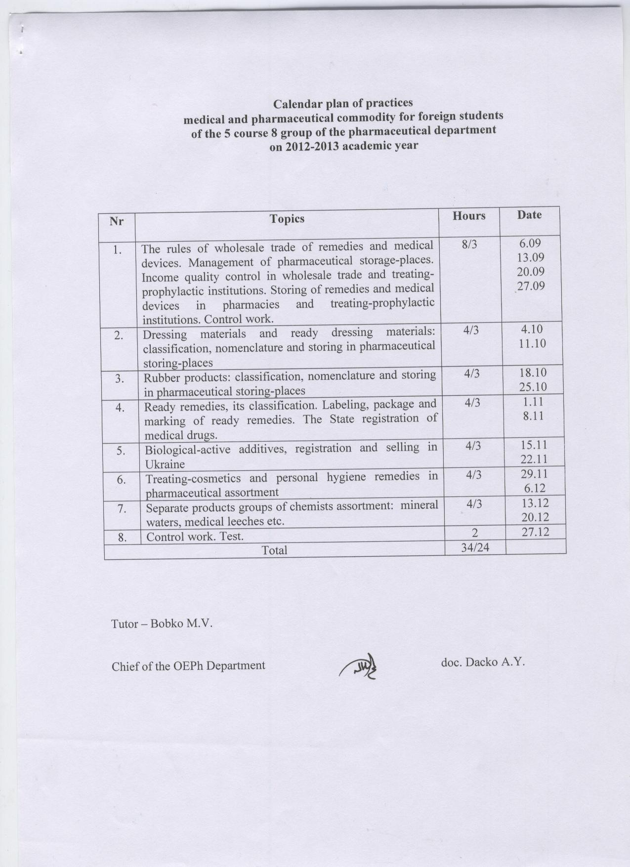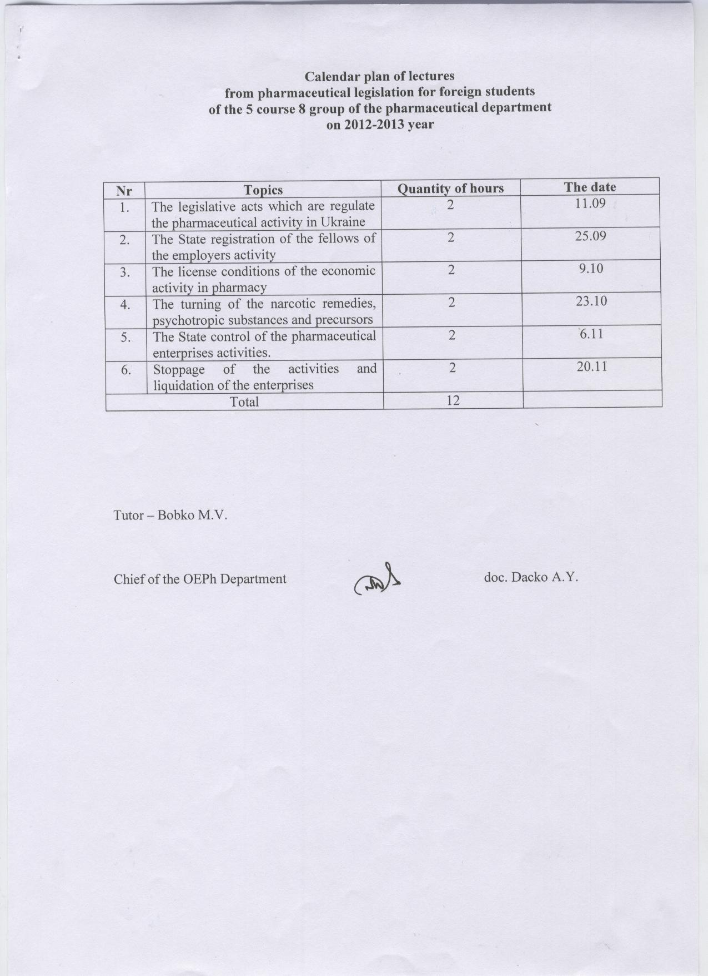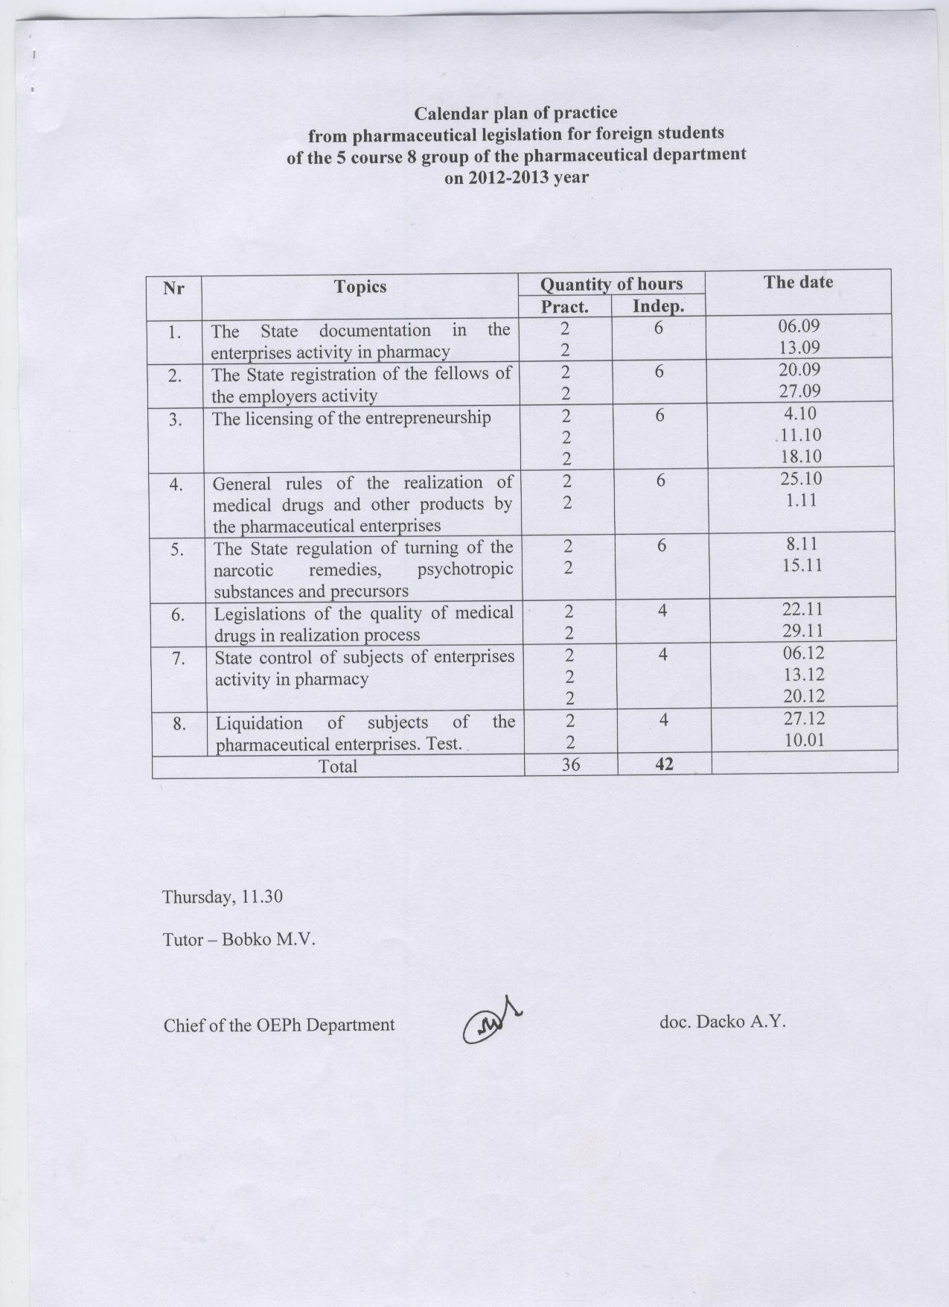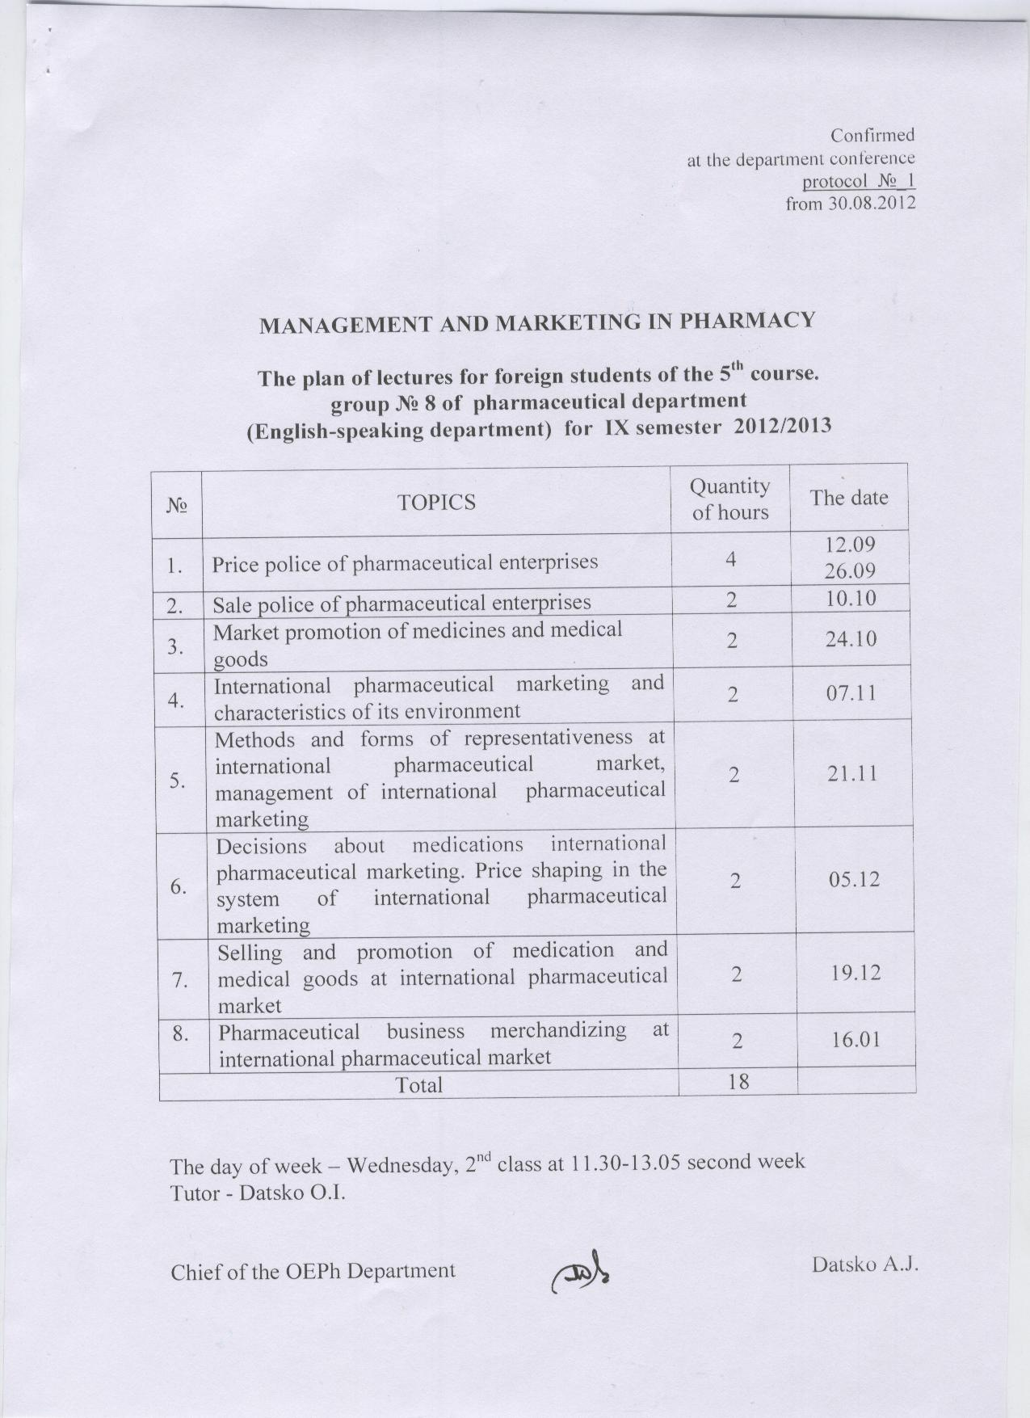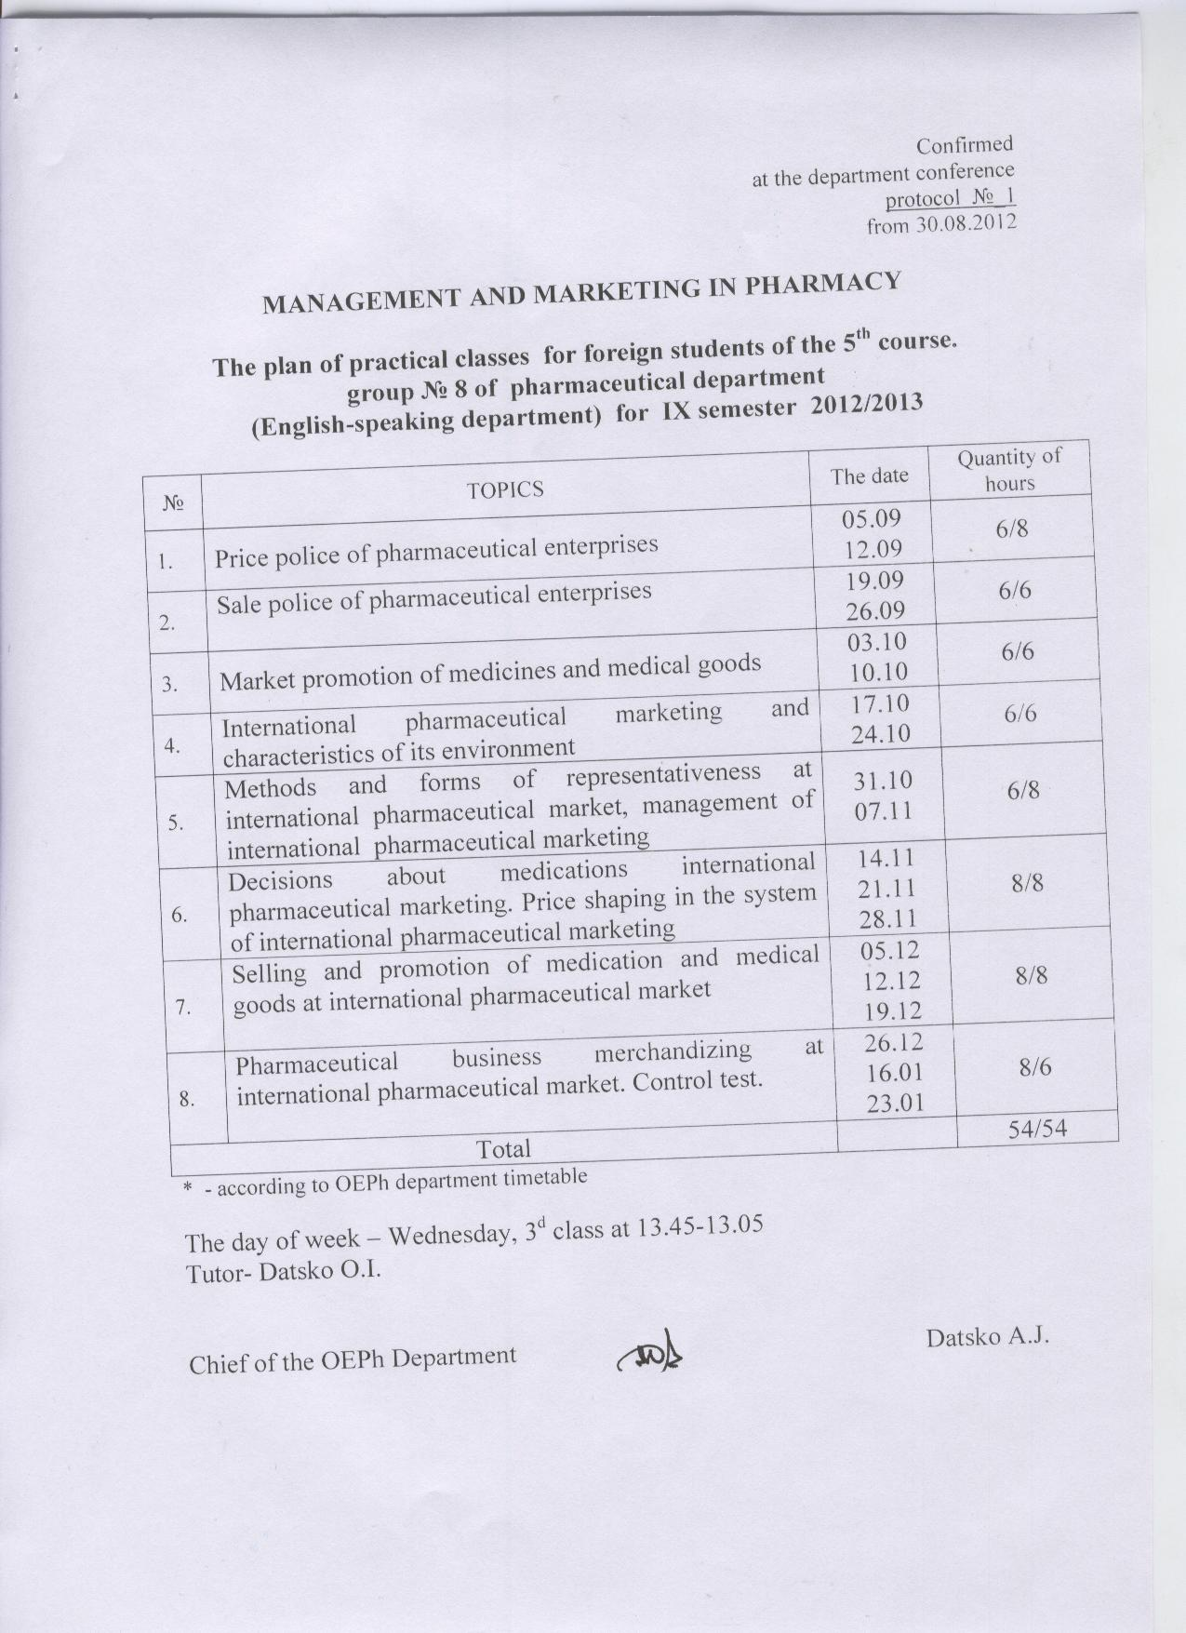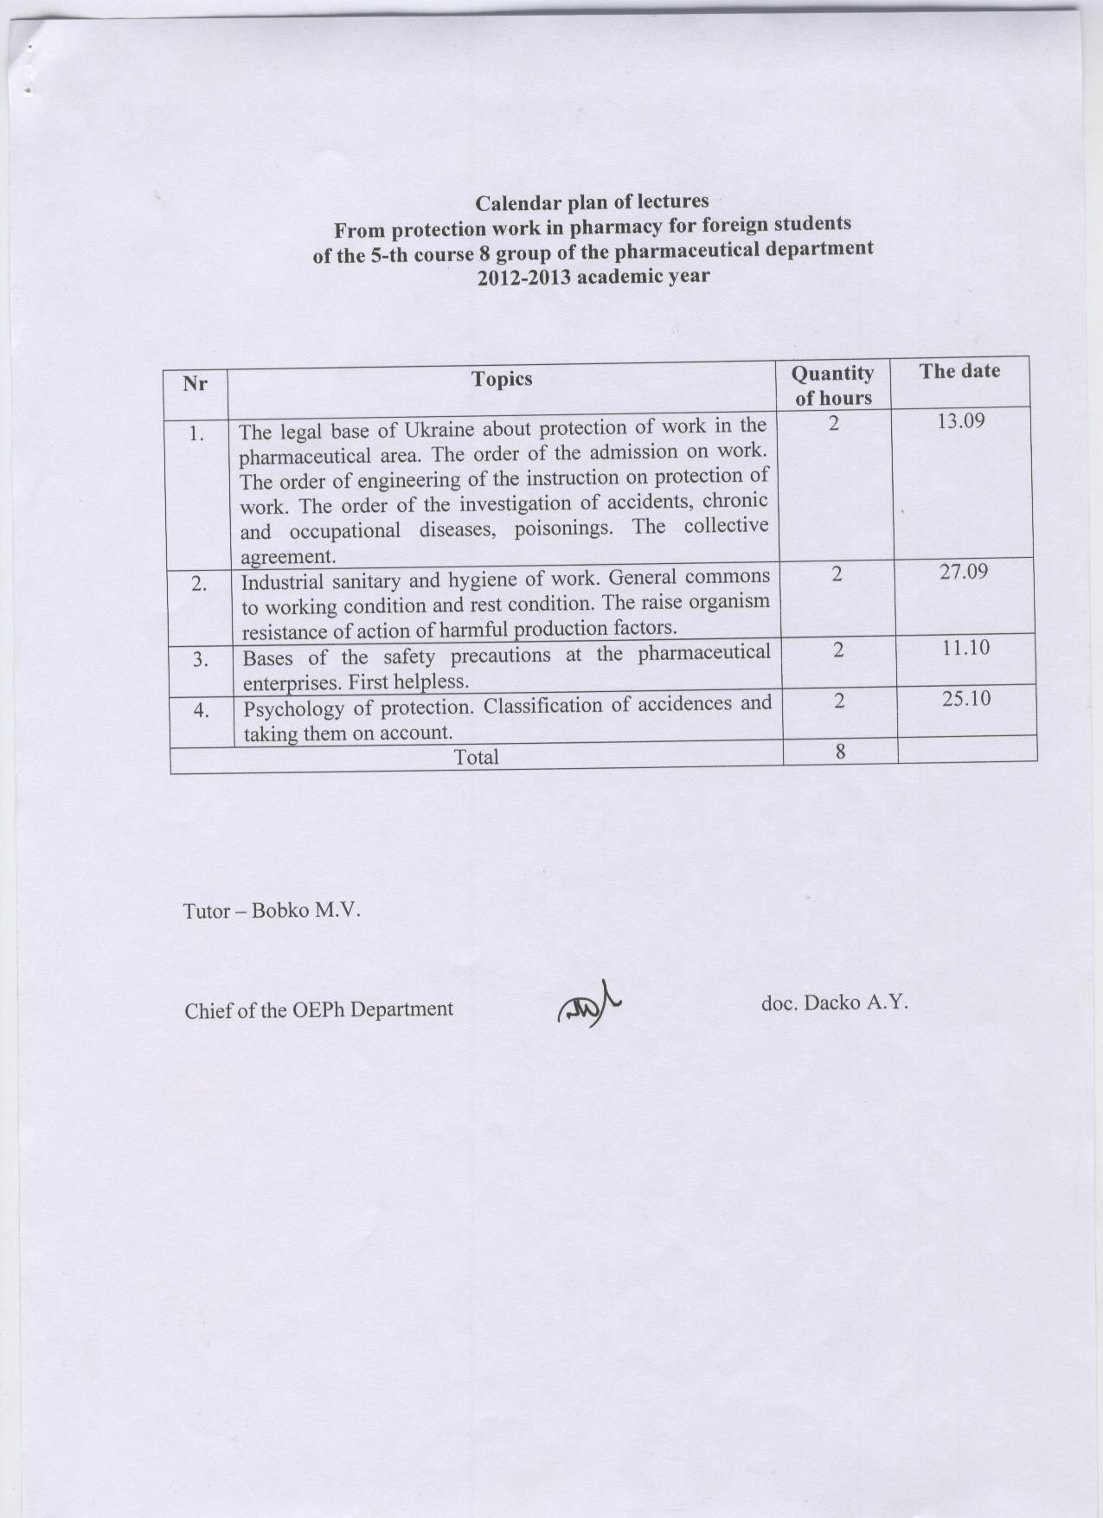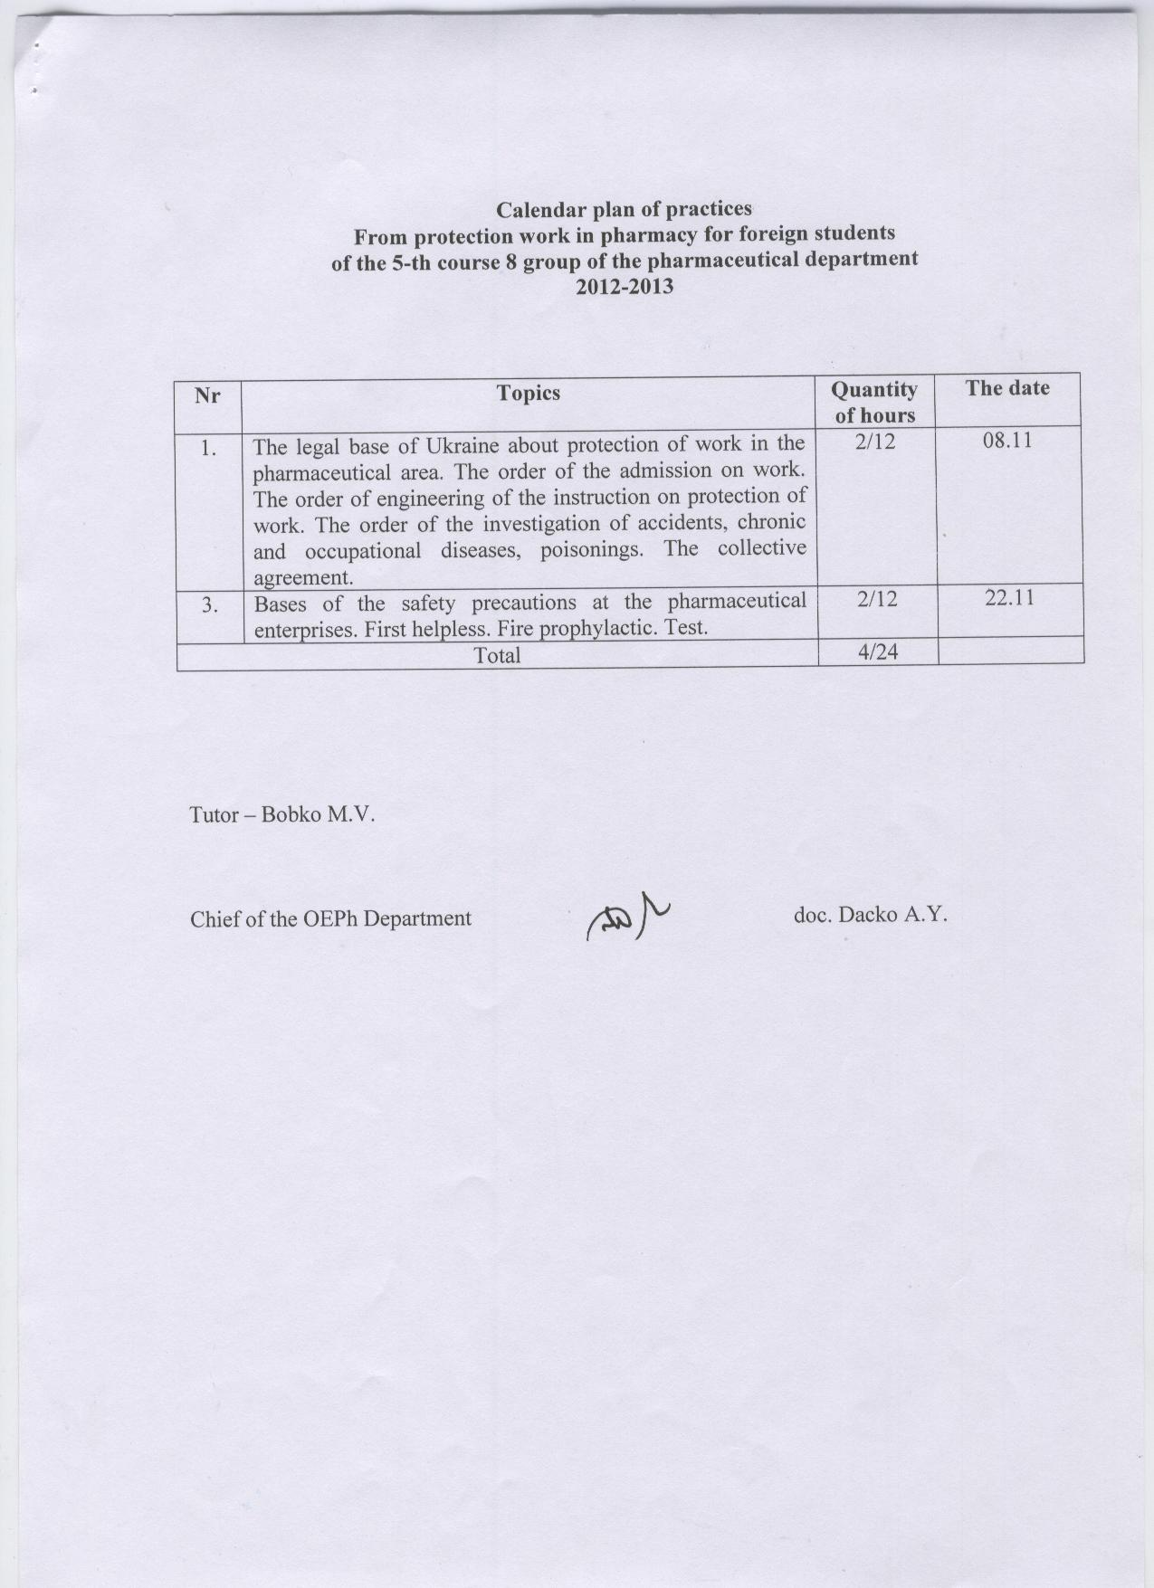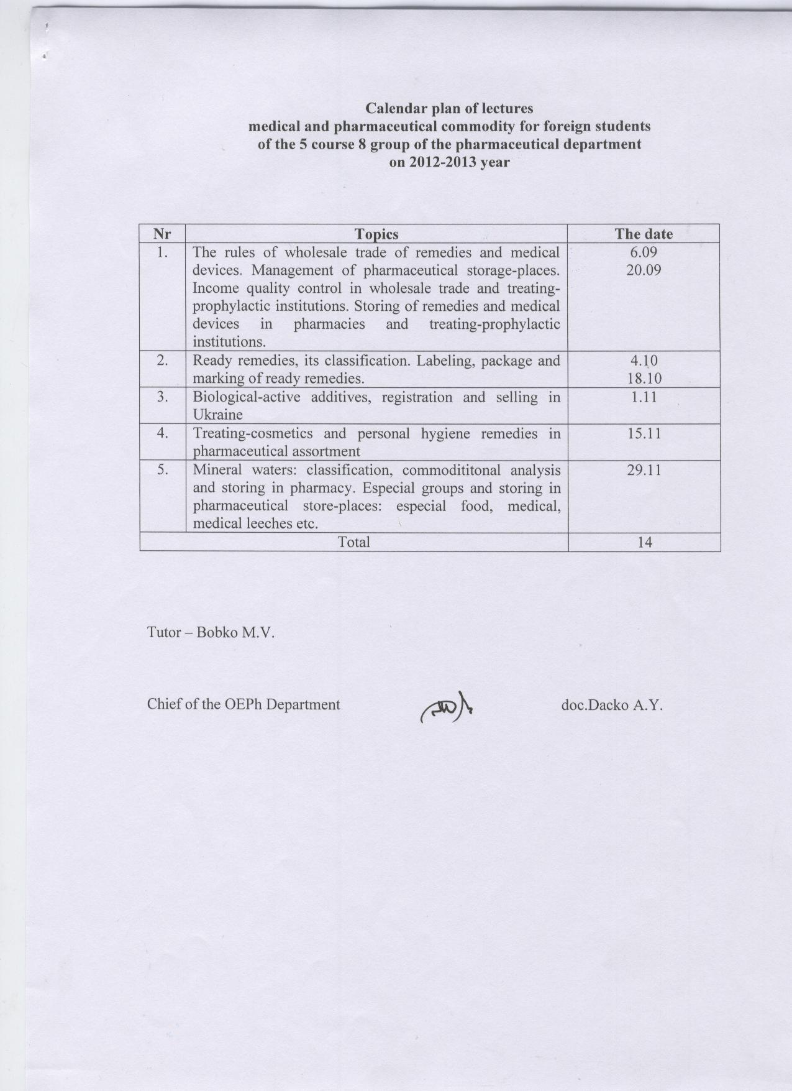 SCHEDULE of LABORATORY LESSONS on Toxicological Chemistry
for Fifth Year Pharmacy Students
Autumn 2012/2013 academic year

Semester duration – 03.09.2012 – 23.01.2013 Lesson duration – 3 hours (beginning 8.30)

No | Theme of lesson | datum
1 | Chemical-toxicological investigation of "medicinal poisons." Isolation of "medicinal poisons" from biological material by polar solvents (indirect analysis). | 07.09.2012
2 | Investigation of acidic extract from biological material on presence of toxic substances of acid, neutral and weak basic character with chemical methods. Detection of barbital, barbamyl, phenobarbital, aspirin, salicylic acid, caffeine, strychnine, and brucine in the extract. "Blind" tests on indicated poisons. | 14.09.2012
3 | Investigation of acidic extract from biological material on presence of toxic substances of acid, neutral and weak basic character with microcrystaloscopic tests and UV-spectrophotometry. TLC-screening. | 21.09.2012
4 | Investigation of basic extract from biological material on presence of toxic substances of weak acid, neutral and basic character with chemical methods. Detection of atropine, cocaine, quinine, morphine, codeine, papaverine, ephedrine, chlorpromazine, chlordiazepoxide, novocaine (procaine), haloperidol in the extract. "Blind" tests on indicated poisons. | 28.09.2012
5 | Investigation of basic extract from biological material on presence of toxic substances of weak acid, neutral and basic character with chemical methods. Detection of atropine, cocaine, quinine, morphine, codeine, papaverine, ephedrine, chlorpromazine, chlordiazepoxide, novocaine (procaine), haloperidol in the extract. "Blind" tests on indicated poisons. | 05.10.2012
6 | Investigation of basic extract from biological material on presence of toxic substances of acid, neutral and weak basic character with microcrystaloscopic tests and UV-spectrophotometry. TLC-screening. | 12.10.2012
7 | Investigation of basic extract from biological material on presence of toxic substances of acid, neutral and weak basic character with microcrystaloscopic tests and UV-spectrophotometry. TLC-screening. | 19.10.2012
8 | Express-analysis of biological fluids (blood, urine) on acute poisoning by derivatives of barbituric acid and opium alkaloids and their synthetic analogues. | 26.10.2012
9 | Express-analysis of biological fluids (blood, urine) on acute poisoning by derivatives of 1,4-benzodiazepine and phenothiazine. | 02.11.2010
10 | Tests: "Toxicological characteristics and methods of analysis of toxic substances isolated from biological material with acidified alcohol or acidified water."  Act of forensic-toxicological investigation of ‘medicinal poisons’. | 09.11.2012
11 | Chemical-toxicological investigation of mineral acids, alkalis and salts.  Isolation of mineral acids, alkalis and salts from biological material. Detection and determination of nitrite in the dialysate. | 16.11.2012
12 | Diagnosis of carbon monoxide poisoning.  Detection and determination of carboxyhaemoglobin. | 23.11.2012
13 | Chemical-toxicological investigation of pesticides.  Methods of pesticides isolation from objects of investigation. Isolation of organophosphate pesticides (OPP) from biological material. Detection of OPP in extracts from biological material by chemical, physico-chemical, and enzyme methods. | 30.11.2012
14 | Methods of pesticides isolation from objects of investigation. Isolation of organophosphate pesticides (OPP) from biological material. Detection of OPP in extracts from biological material by chemical, physico-chemical, and enzyme methods. | 07.12.2012
15 | Quantitative determination of OPP in extracts from biological material by photocolorimetric and enzyme methods. | 14.12.2012
16 | Analysis of biological material on organomercury pesticides. | 21.12.2012
17 | Tests: "Chemical-toxicological studies of mineral acids, alkalis and salts, carboxyhaemoglobin and pesticides."  Act of forensic toxicological investigation of pesticides. | 29.12.2012
18 | Tests on practical ability on toxicological chemistry. | 05.01.2013
Total: 54 hours

SCHEDULE of LECTURES
on Toxicological Chemistry for Fifth Year Pharmacy Students
Autumn 2012/2013

Semester duration – 03.09.2012 – 23.01.2013

No | Theme of lecture | datum
1. | Application, toxicilogical description, methods of isolation from biological material and analysis methods of pyridine, piperidine, tropane, quinoline, phenanthroisoquinoline derivates and their synthetic analogues, acyclic alkaloids (ephedrine).  Application, toxicilogical description, methods of isolation from biological material and analysis methods of phenothiazine, 1,4-benzodiazepine, p-aminobenzoic acids, imidazoline (clophelin) derivetes. | 14.09.2012
2. | Pesticides. Application, classification and toxicological significance. Physical and chemical properties of pesticides-derivates of phosphoric acid and chlorine-organic substances. Toxicokinetics. Methods of isolation from biological material, methods of extracts clarification and its analysis. | 12.10.2012
3. | Pesticides-derivates of carbaminic acid and pyrethroids. Physical and chemical properties. Toxicokinetics. Methods of isolation from biological material, methods of extracts clarification and its analysis.  Physical and chemical properties of carbon(II) oxide, their toxic action. Detection and quantitative determination of carboxyhemoglobin in blood. | 09.11.2012
Total: 6 hours

Thematic plan of the lectures
on Resources of medicinal plants
for the students of У course of pharmaceutical faculty
for autumn semester 2012-2013 study years

№№ | Themes of the lectures | Hours
1. | Current state and dynamics for application of resources of wild-growing plants. Current importance of plants in economy and medicine. Resources of medicinal plants as a science and academician subject: objectives, major tasks, terminology. | 2
2. | Geobotanical fundamentals of Resources of medicinal plants. Importance of ecology for the subject | 2
3. | Major stages of resources research. Preparatory works. Rare phytocenoses of the western regions of Ukraine. | 2
4. | Research methods for stocks of wild-growing medicinal plants. | 2
5. | Drawings on the maps medicinal herbs growth places (distribution) and their stocks. | 2
6. | Legislation acts on uses of medicinal plant resources. Importance of resources research works in protection of wild-growing medicinal plants. Medicinal plants of Lviv region, measures on their protection and recreation. | 2
 | Total: | 12

Thematic plan of the laboratory works
on Resources of medicinal plants
for the students of У course of pharmaceutical faculty
for autumn semester 2012-2013 study years

№№ | Theme of the laboratory works | Hours
1. | Introduction to phytotherapy resources survey. Its subject and content. | 2
2-4. | Preparatory stages of resource investigations:  - formation of tasks of resource investigations, based on needs of drug-stores and pharmaceutical manufactures  - detection of potentially-productive fields and medicinal plants, perspective for resource investigations  - choice and preparation of mapping materials, developing of tracks | 2  2  2
5. | Associations of medicinal herbs, their value in search of necessary plants. | 2
6. | Stocks of vegetative raw materials. Biological and operational stocks. Estimation of stocks on key parts and concrete growing places | 2
7. | Methods of medicinal plants productivity determination. Calculation of exploitative stocks | 2
8. | Research of productivity and stocks of wild-growing herbs by a method of registration parts. | 2
9. | Research of productivity and stocks of wild-growing herbs by a method of projective covering. | 2
10. | Research of productivity and stocks of wild-growing herbs by a method of modeling specimen | 2
11. | Determination of possible annual harvesting of MPM. Inventarization checklists | 2
12. | Mapping of grow places and MPM stocks | 2
13. | Estimation of economic effectiveness of use determined medicinal plant materials stocks in various grow places and geomorphological regions | 2
14. | Development of calendar and perspective plans MPM harvesting, based on nomenclature and location | 2
15. | Rules of rational gathering and storage of medicinal plant materials. | 2
16. | Rules of rational use of medicinal plant materials resources. | 2
17. | Actions on reservation and recreation of natural resources of herbs. | 2
18. | Credit | 2
 | Total: | 36

Thematic plan of independent work
on Resources of medicinal plants
for the students of У course of pharmaceutical faculty
for autumn semester 2012-2013 study years

№№ | Themes of independent work | Hours
1. | Medicinal plants of various phytocenoses in Ukraine | 4
2. | Detection of potentially productive tracts and plant growth places of medicinal plants, that are perspective for resource investigations | 4
3. | Drawing-up of map-schemes of areas of medicinal plants in Lviv region | 4
4. | Development of working routes for determination of stocks of medicinal plants, grown in Lviv region | 4
5. | Determination of productivity and exploitative stocks of medicinal plants on concrete growth places. Mapping of determined stocks | 4
6. | Working out of measures for preservation of medicinal plant stocks and organization of their rational uses | 4
 | Total: | 24

SCHEDULE OF PRACTICAL CLASSES
ON TECHNOLOGY OF MEDICINAL COSMETICS
for the 5 year students of the Pharmaceutical Faculty
9th semester

№ | Topic | Duration
 | Cosmetics, their classification and characteristic. Normative documents concerning manufacturing of cosmetics and medicinal cosmetics. | 2
 | Parameters of quality and norm of safety of cosmetics and medicinal cosmetics. | 2
 | Skin, structure and functions of a skin. The characteristic of the types of a skin and hair. Methods of investigations. | 2
 | Main skin problems and pathologies. | 2
 | Ingredients of cosmetics, their classification, characteristic and features of use. Principles of development of cosmetics. | 2
 | Seminar: Legislative aspects of development, manufacture and realization of cosmetics. Ingredients of cosmetics, their technological, biopharmaceutical and cosmetological evaluation. | 2
 | Solid medicinal cosmetics. Powder. Technology, quality control and use. | 2
8. | Liquid medicinal cosmetics. Lotions and tonics. Technology, quality control and use. | 2
9. | Semi-solid medicinal cosmetics. Cosmetics based on the emulsion systems. Technology, quality control and use. | 2
10. | Fatty creams. Technology, quality control and use. | 2
11. | Non-fatty creams. Cosmetics based on the gel bases. Technology, quality control and use. | 2
12. | Suspension cosmetic products. Cosmetic scrubs and masks. | 2
13. | Control work: Dosage forms of medicinal cosmetics, their technology. | 2
14. | Extemporaneous medicinal cosmetics for treatment pathologies of grease and perspiring glands. | 2
15. | Extemporaneous medicinal cosmetics for treatment fungal and others infection diseases of skin. | 2
16. | Technology and quality control of tooth powders, toothpastes and liquid cosmetic products for oral cavity. | 2
17. | Technology and quality control of deodoring cosmetic products. | 2
18. | Control work: Particularities of technology of medicinal cosmetics in different dosage forms. Safety and parameters of quality of medicinal cosmetics. | 2
 | total | 36
SCHEDULE OF LECTURES

ON TECHNOLOGY OF MEDICINAL COSMETICS
for the 5 year students of the Pharmaceutical Faculty
9th semester

№ | Topic | Duration
1. | Cosmetology as a science. Cosmetics, their classification and characteristic. Normative documents concerning manufacturing of cosmetics and medicinal cosmetics. Safety of cosmetics product, methods of investigations. | 2
2. | Skin as an object of influence of cosmetics. Anatomical, physiological and biochemical peculiarities of skin aging. Main skin problems and pathologies. | 2
3. | Ingredients of cosmetics, their classification and characteristic. Technological, biopharmaceutical and cosmetological evaluation of the main groups. Principles of development of cosmetics. | 2
4. | Dosage forms of medicinal cosmetics. Technology of solid and liquid medicinal cosmetic products. Quality control. | 2
5. | Cosmetics creams, classification, characteristic. Technology of creams and quality control. | 2
6. | The basic principles of a complex cosmetic care of a skin. New bases of active substances and moden technologies in manufacturing of medicinal cosmetics. | 2
 | total | 12

QUESTIONS FOR SELF-TRAINING

of TECHNOLOGY OF MEDICINAL COSMETICS
for the 5 year students of the Pharmaceutical Faculty
9th semester

№ | Topic | Duration
1. | The definitions of main terms: “cosmetics”, “cosmetology”, “cosmeceutics”, “cosmetics product”, “medicinal cosmetics”. | 2
2. | Normative documents concerning development, manufacture and realization of cosmetics and medicinal cosmetics. | 4
3. | General principles of pharmaceutical care of patient with cosmetic problems. | 3
4. | Role of cosmetic care in prophylaxis of skin problems and pathologies . | 3
5. | Cosmetic products for protection of skin from damaging  environmental factors, particularities of technology and use. | 3
6. | Plants raw materials in compositions of cosmetics. | 3
7 | Ingredients of animal origions in cosmetic compositions. | 3
8. | Auxiliary substances in technology of different cosmetic products. | 4
9. | Surface-active agents in cosmetic products. | 4
10. | Cosmetic procedures, methods of aplications. | 4
total |  | 33

SCHEDULE OF LECTURES
ON biopharmaceutics
for the 5 year students of the Pharmaceutical Faculty
9th semester

№ | Topic | Duration
1. | Biopharmaceutics as an academic and scientific discipline. The main directions of biopharmaceutical investigations. Biopharmaceutical classification system of medicinal substances | 2
2. | Bioavailability and pharmaceutical availability. Assessment of pharmaceutical availability as the criterion of medicinal preparations quality | 2
3. | Methods for the determination of pharmaceutical availability of medicinal preparations for oral administration and semi-solid preparations. | 2
Total |  | 6

ON biopharmaceutics
for the 5 year students of the Pharmaceutical Faculty
9th semester

№ | Topic | Duration
1. | Medicinal product and dosage form. Biopharmaceutical classification system of drug substances. Criteria for medicinal preparations quality | 2
2. | Pharmaceutical availability, methods of assessment. Devices and materials for assessment of pharmaceutical availability. Evaluation criteria, interpretation of results, validation | 2
3. | Investigation of drug substances physico-chemical properties influence on the release rate of drug substances from semi-solid preparations for cutaneous application | 2
4. | Investigation of excipients influence on the release rate of drug substances from tablets produced by different manufacturers | 2
5. | Investigation of excipients influence on the release rate of drug substances from capsules | 2
6. | Investigation of simple chemical modification of drug substances influence on the release rate of drug substances from semi-solid preparations for cutaneous application (ointments) | 2
7. | Investigation of excipients and type of dosage form influence on the release rate of drug substances from semi-solid preparations for cutaneous application (ointments, creams and gels) | 2
8. | Investigation of pharmaceutical availability of rectal and vaginal suppositories | 2
9. | Control paper: "Investigation of biopharmaceutical availability of the oral preparations". Seminar: “Pharmaceutical and biological availability as criteria of medicinal preparations quality, effectiveness and safety” | 2
Total |  | 18

QUESTIONS FOR SELF-TRAINING

ON biopharmaceutics
for the 5 year students of the Pharmaceutical Faculty
9th semester

№ | Topic | Duration
1. | Biopharmaceutics and physicochemical problems of emulsions and suspensions manufacturing and application. Release and bioavailability of drug substances from these dosage forms | 5
2. | Inhalation administration of drugs. Factors affecting the pharmaceutical and biological availability of drug substances from aerosols | 5
3. | Biopharmaceutical problems of eyes preparations, ocular therapeutic systems (Ocusert). Factors affecting the quality and bioavailability of eyes preparations | 5
4. | Impact of physiological and pharmaceutical factors on pharmaceutical availability and absorption kinetics of drug substances from rectal and vaginal preparation | 5
5. | Bioequivalence of medicinal products as the quality criterion | 5
6. | Rational use of medical products as the important criterion of their effectiveness | 5
total |  | 30

SCHEDULE OF LECTURES
ON GOOD PHARMACEUTICAL PRACTICES
for the 5 year students of the Pharmaceutical Faculty

№ | Topic | Duration
 | Good pharmaceutical practices (GXP). | 2
 | Principles and rules of pharmaceutical development of drug products. | 2
 | Good Manufacturing Practice (GMP) - basis assurance of quality for drug products. | 2
 | Requirements of good manufacturing practice (GMP) to manufacturing process. | 2
 | Using of good storage practice (GSP) and good distribution practice (GDP) for realization of medicinal product. | 2
 | Conception to good pharmacy practice (GPP). | 2
Total |  | 12

SCHEDULE OF PRACTICAL CLASSES
ON GOOD PHARMACEUTICAL PRACTICES
for the 5 year students of the Pharmaceutical Faculty

№ | Topic | Duration
 | “Life cycle” of the drug products. Assurance of quality. | 2
 | Pharmaceutical development of drug products. | 2
 | Pharmaceutical development of liquid and semi-solid preparations, requirements to the researches. | 2
 | Pharmaceutical development of formulated products, transdermal patches, pressured metered dose preparations for inhalation and dry powder for inhalation , requirements to the researches.. | 2
 | The rules of GLP (Good laboratory practice). Using of GLP standards for preclinical investigation of drug product. Requirements to preclinical investigation according to the kind of dosage form. | 2
 | Requirements to determination of generic equivalence. Principles of refering generics drugs to the waiver category. | 2
 | GCP (Good clinical practice). Purpose , basic principles and requirements of GCP | 2
 | Registration of drug products in Europe. Normative document. Structure of registration file. | 2
 | Guidance on Good Manufacturing Practices (GMP). Quality management. Personnel qualifications. | 2
 | Guidelines on Good Manufacturing Practices (GMP). Requirements to premises and equipment. | 2
 | Guidelines on Good Manufacturing Practices (GMP). Requirements to manufacturing process. | 2
 | Requirements documents according to Good Manufacturing Practices. Types of manufacturing documents. Form and content of standard workings methods, manufacturing specifications (Specifications and testing procedures. Specifications for starting and packaging materials. Specifications for intermediate and bulk products. Specifications for finished products. Master formulae). | 2
 | Making changing in technological and analytical documentation. Classification of changes and their expert. | 2
 | Requirements of Good Manufacturing Practices for contract production and analysis. The contract giver and contract accepter. Self-inspection and quality audits. | 2
 | Guidance on good storage practices for drug product. | 2
 | Guidelines on good distribution practice of drug product. | 2
 | Conception of good pharmacy practice (GPP). | 2
 | Pharmaceutical care of patients at the realization of drug product. | 2
Total |  | 36

QUESTIONS FOR SELF-TRAINING
ON GOOD PHARMACEUTICAL PRACTICES
for the 5 year students of the Pharmaceutical Faculty

№ | Topic | Duration
 | Acquaintance with basic terms of guidelines: CPMP/QWP/155/96 « Drug products. Good manufacturing practice»; CPMP/QWP/054/98 « Drug products. Pharmaceutical development», «Drug products. Auxiliary matters» | 3
 | Development of peritoneal dialysis solutions. Requirements to their researches. | 4
 | Guidance for industry. Sterile drug products. Produced by aseptic processing — Current Good Manufacturing Practice. | 5
 | Requirements of good manufacturing practice to the manufacturing biological, radio-active drug products and medical gases. | 5
 | Test procedures of herbal drug. Requirements of good manufacturing practice to the manufacturing herbal drug. | 3
 | Acquaintance with the structure of registration file. Registration of drug products in Europe. Normative documents. | 5
 | Requirements to the chemical, pharmaceutical and biological documentation. | 5
 | Research of drug toxicity. Classification of drug products according to toxicity.Criterias of toxicity . | 5
 | Acquaintance with the nomenclature of auxiliary matters. Requirements to the auxiliary matters. List of auxiliary matters which must be necessarily specified on packing. | 5
 | Guidelines on good distribution practice of medicinal product. Acquaintance with basic terms of guidelines 94/C63/03” Guidelines on good distribution practice of medicinal product for human use”. | 5
 | Requirements to making non-sterile drug products in the pharmacies. | 5
 | Requirements to making sterile drug products in the pharmacies. | 5
 | Pharmaceutical care of patients at the time of realization of medicinal product in the pharmacies. | 5
 | TOTAL | 60

Thematic plan of lectures
on “Medicinal Plants and Phytotherapy”
for the students of У course of pharmaceutical faculty
for spring semester 2012-2013 study years

№ № | Themes of lectures | Hours
1. | Phytotherapy as a science. Fundamentals, major principles and tasks of modern phytotherapy. Advantages and disadvantages of of phytotherapeutic remedies. Phytomedicines, methods of preparation from the dried and fresh medicinal plant material. | 2
2. | Phytotherapy of the cardiovascular, circulatory and lymphatic systems and neuroses. | 2
3. | Phytotherapy of the respiratory system, oral and pharyngeal disorders | 2
4. | Phytotherapy of the gastrointestinal system, liver and kidneys. | 2
5. | Phytotherapy of the endocrine system and metabolic diseases. Phytotherapy in dermatology and medical costemology. | 2
 | Total: | 10

Thematic plan of laboratory works
on “Medicinal Plants and Phytotherapy”
for the students of У course of pharmaceutical faculty
for spring semester 2012-2013 study years

№№ | Themes of laboratory works | Hours
1. | Fundamentals of phytotherapy. Rules for composition and analysis of herbal collections and teas. Standardization, types of analytical and normative documentation for medicinal plant materials, herbal collections, phytomedicines. | 4
2. | Poisonous and drastic plants in phytotherapy. Diagnostics of poisonous adulterants in phytomedicines, principles of first aid in cases of poisoning. | 4
3. | Phytotherapy of the cardiovascular, circulatory and lymphatic systems and neuroses. | 6
4. | Phytotherapy of the respiratory system. | 4
5. | Phytotherapy in otolaryngology. | 4
6. | Phytotherapy of the gastrointestinal system. | 4
7. | Phytotherapy of the liver and biliary complaints. | 6
8. | Phytotherapy of the kidney and urinary tract disorders. | 4
9. | Phytotherapy of the endocrine system and metabolic diseases. | 4
10. | Phytotherapy in ophthalmology. | 4
11. | Phytotherapy in dentistry. | 4
12. | Phytotherapy in dermatology and medical costemology. | 6
13. | Phytotherapy in obstetrics and gynecology. | 4
14. | Phytotherapy in pediatrics. | 4
15. | Principles of diet therapy. Phytotherapeutical properties of food, agricultural, technical, aromatic and spicy plants. Phytodietetics, phytohygiene, phytobalneology. | 4
16. | The bases and principles of aromatherapy: objects, means and methods | 4
17. | Phytotherapy of allergic complaints. | 6
18. | Phytotherapy in oncology. | 4
19. | Phytotherapy for prophylaxis and treatment of radiation sickness. | 4
20. | Medicinal plants and materials that influence the immune system. | 4
21. | Phytotherapy of hypo- and avitaminosis. Role of microorganisms in the human vital activity. Medicinal plants as the sources of microelements. | 4
22. | Control work: Development and substantiation of phytotherapeutical medicines | 4
23. | Credit | 2
 | Total: | 98

Thematic plan of independent work
on “Medicinal Plants and Phytotherapy”
for the students of У course of pharmaceutical faculty
for spring semester 2012-2013 study years

№ № | Themes of independent work | Hours
1. | Medicinal plants and medicinal plant materials (MPM) in the complex treatment of infectious diseases | 8
2. | Medicinal plants and medicinal plant materials in the complex treatment of joint and bone complaints. | 8
3. | Аеrоphytotherapy: principles, methods. | 8
4. | Аstrology and phytotherapy: principles, methods. | 8
5. | Medicinal plants in homeopathy. | 14
6. | Perspectives for uses of fungi, mosses, lichens in medicine and pharmacy. | 7
7. | Phytochemical screening of MPM. Determination of technological and butch quality indices of MPM. | 25
8. | Reference search and analysis of herbal compositions, used in the scientific and folk world medicine for the treatment of various diseases. | 30
 | Total: | 108

